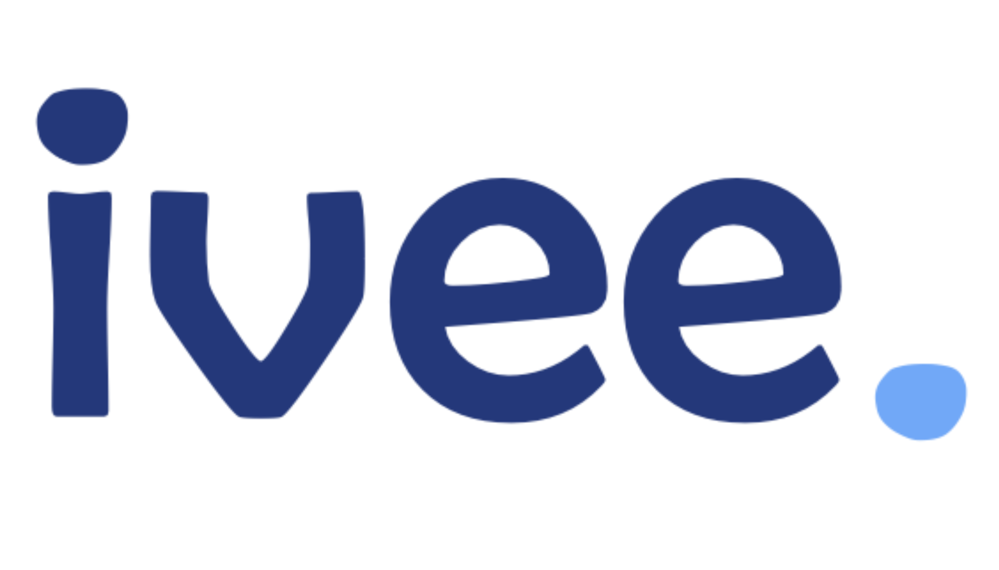

### **Questions About the Role**

* **Day-to-Day Responsibilities:**
  + Can you describe a typical day or week in this role?
  + What are the most immediate priorities for someone in this position?
  + What are the key challenges someone in this role might face?
* **Expectations:**
  + What are your expectations for the first 3-6 months in this role?
  + How is success measured in this position?
  + How often do performance reviews occur, and what is the process?
* **Growth Opportunities:**
  + Are there opportunities for professional development and training?
  + What are the potential career paths for someone in this role?
  + How does the company support employees in advancing their careers?

### **Questions About the Team and Company Culture**

* **Team Dynamics:**
  + Can you tell me about the team I’ll be working with?
  + How does the team typically collaborate on projects?
  + What is the management style of the team leader or manager?
* **Company Culture:**
  + How would you describe the company culture?
  + How does the company promote a healthy work-life balance?
  + Can you share examples of how the company supports employees returning from a career break?
* **Diversity and Inclusion:**
  + How does the company approach diversity and inclusion?
  + Are there any employee resource groups or networks for women or parents?
  + How does the company support employees with diverse backgrounds or life experiences?

### **Questions About Training and Onboarding**

* **Onboarding Process:**
  + What does the onboarding process look like for new hires?
  + Are there specific training programs for employees returning after a career break?
  + How long is the typical training period before new hires are expected to work independently?
* **Mentorship and Support:**
  + Is there a mentorship program available for new employees?
  + How does the company support employees in updating their skills after a career break?
  + What resources are available for continuous learning and development?

### **Questions About Work-Life Balance and Flexibility**

* **Work Schedule:**
  + What is the typical work schedule, and is there flexibility in hours?
  + Are there options for remote work or a hybrid work model?
  + How does the company accommodate employees with family or caregiving responsibilities?
* **Support Systems:**
  + Are there any programs in place to help employees manage work-life balance?
  + How does the company handle situations where employees need to take time off for personal reasons?
  + Are there any benefits or policies specifically designed for parents or caregivers?

### **Questions About Company Stability and Future**

* **Company Growth:**
  + How has the company grown or changed over the past few years?
  + What are the company’s goals for the next 3-5 years?
  + How does the company plan to stay competitive in the industry?
* **Financial Stability:**
  + Can you provide any insights into the company’s financial health?
  + How has the company responded to recent industry changes or economic challenges?
  + What steps does the company take to ensure long-term stability and growth?

### **Questions About the Interview Process**

* **Next Steps:**
  + What are the next steps in the interview process?
  + When can I expect to hear back about the decision?
  + Will there be additional interviews or assessments?
* **Interview Feedback:**
  + Is there anything in my background or experience that you would like more information about?
  + Are there any concerns about my fit for the role that I could address now?
  + How does the company approach interview feedback for candidates?